Upper case and Lower case:

Aim:
To write a C program to read a text and count the number of uppercase and lowercase alphabetic characters.

Algorithm:
- Start the program.
- Declare a character array to store the input text.
- Initialize the uppercase and lowercase counters to zero.
- Read the text using fgets().
- Scan each character in the text.
- If the character is uppercase, increment the uppercase counter; if it is lowercase, increment the lowercase counter.
- Display the total number of uppercase and lowercase characters.
- Stop the program.

Pseudo code:
BEGIN
DECLARE text[1000]
upper = 0
lower = 0

READ text

FOR each character in text
IF character is uppercase THEN
upper = upper + 1
ELSE IF character is lowercase THEN
lower = lower + 1
END IF
END FOR

DISPLAY "Uppercase characters", upper
DISPLAY "Lowercase characters", lower
END

Code:
#include <stdio.h>
#include <ctype.h>
int main()
{
char text[1000];
int i, upper = 0, lower = 0;
printf("Enter the text: ");
fgets(text, sizeof(text), stdin);

for (i = 0; text[i] != '\0'; i++)
{
if (isupper((unsigned char)text[i]))
upper++;
else if (islower((unsigned char)text[i]))

lower++;
}

printf("Uppercase characters = %d\n", upper);
printf("Lowercase characters = %d\n", lower);

return 0;
}

Output:
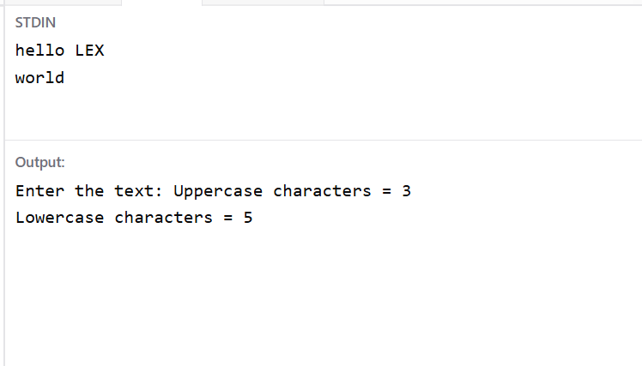

Result:
Thus, the program was executed successfully to count the uppercase and lowercase alphabetic characters in the given text. For the input helloLEX world, the output is 3 uppercase characters and 8 lowercase characters.

